Introduction

Despite significant project and program management advancements, far too many projects fail. Either they fail to meet cost, schedule, or content commitments or they do not deliver the intended value even when meeting them. This book provides the principles and practices for delivering valuable development efforts.

Throughout the book, we address both project and program management:

* *Project management* is focused on delivering specific deliverables within a defined scope, timeline, and budget
* *Program management* coordinates and oversees multiple related projects to achieve broader strategic goals and business outcomes.

Program management operates at a higher level and is more strategic, while project management is more tactical and focused on executing individual projects.

*The book will refer to Project and Portfolio Management as ‘PPM.’*

## Project Failure is Still All Too Prevalent

Despite significant project and program management attention (Project Management Institute, 2023), the inability to meet stakeholder commitment remains notably high. This includes inability to meet obejctives in one or more dimensions:

* Cost
* Schedule
* Technical performance/requirements

Here are a few examples of projects that were abandoned due to overruns:

* Airbus A380 Freighter Program

The Airbus A380 Freighter variant was launched in the early 2000s to compete in the large cargo aircraft market. Major logistics companies, including UPS and FedEx, initially placed orders. However, production delays and escalating costs plagued the program. By 2006, FedEx canceled its order, citing delivery delays, followed by UPS in 2007. With no remaining orders, Airbus officially canceled the A380 Freighter program.

Reference: https://simpleflying.com/ups-cancelled-a380-order/

* NHS National Programme for IT (Dolfing 2019; “National Health Service – UK” 2008)

Initiated in 2002, the National Programme for IT aimed to revolutionize healthcare delivery in the UK through comprehensive digitization. The program encountered significant challenges, including escalating costs (from an initial £6.4 billion to nearly £10 billion), missed deadlines, and technical and managerial issues. Vendors like Accenture and Fujitsu withdrew, citing difficulties in delivering the required systems. By 2011, the UK government discontinued the program, leaving the NHS without the anticipated integrated digital infrastructure.

* Future Combat Systems (FCS) Program (Feickert 2006; Gates 2014; “Defense Acquisitions: Key Decisions to Be Made on Future Combat System” 2007)

The Future Combat Systems (FCS) program was initiated by the U.S. Army in 2003 and canceled in 2009. It was intended to be a revolutionary modernization effort to create a fully integrated, networked battlefield. It encompassed 18 individual systems, including manned and unmanned vehicles, advanced communications, surveillance sensors, and precision weaponry, all tied together by an overarching information network. The ambitious program aimed to enable rapid response and superior situational awareness for U.S. military forces. Initially budgeted at $92 billion, estimates eventually grew to over $200 billion. Meanwhile, the system engineers did not achieve interoperability and reliability across systems to provide sufficient value to continue the program.

There is also no lack of examples of projects that were delivered but had disappointing value:

* Concorde Supersonic Airliner (1976-2003)  
  Developed collaboratively by British and French aerospace companies, the Concorde was delivered on time and within budget. Despite being a technological marvel, its high operational costs, limited passenger capacity, and environmental concerns   
  rendered it commercially unviable. The aircraft was retired in 2003, marking it as an iconic but economically ineffective project. (“Why Concorde Was a Failure” 2003; Bremmer 2003)
* Google Glass (2013-2015)  
  Google Glass, a wearable technology innovation, was delivered on time and within budget. However, privacy concerns, limited functionality, and high costs led to poor consumer adoption. Google eventually discontinued the consumer version, although it continues to explore enterprise applications in the technology field (Metz 2019; Kovach 2015).

US Navy Ship (Smart 2020):

“Littoral” means the area near the shore. The Littoral Combat Ship was planned to be cheap and have modular capability, allowing for a range of applications, including minesweeping and above- and below-surface warfare, all of which had reduced crew sizes.

The initial plan was to purchase 55 ships at $220 million each, but the cost of the first 32 is now expected to be $655 million each. Operating costs also increased due to increases in crew sizes. This increased production costs as the large, fixed cost to produce two different designs doubled that required for one. In addition to the large cost overruns, the development schedule tripled from three years to nine. Technical requirements, including minimal crew size, were cut to contain cost growth, leading to performance shortfalls. The primary surface vehicle missile was canceled. The modular approach also had to be abandoned.

# A Unified Approach to Project and Portfolio Management

There are a myriad of practices and processes that can lead to stovepiped organizations, such as earned value management, cost and schedule estimation, budget formulation and execution, risk management, agile development, portfolio management, and so on. We show in this book how these can be both unified and evolved by applying two fundamental principles:

1. A development project is a capital-intensive initiative designed to generate planned benefits *that are successful when they receive the desired return.*
2. *The project and portfolio parameters are almost always uncertain and should be managed using applied probability.*

These potential benefits are often called a *return on investment (ROI)*. In other words,project sponsors commit resources to projects with the expectation of receiving the anticipated ROI.

PPM investments are more complicated than financial investments because:

* The benefits, costs, and schedules are uncertain.
* One can take action throughout the project’s and program’s lifetime to improve the probability of getting the desired ROI.

We believe this is the root cause of PPM failures:

A root cause of these poor outcomes is failing to account for and apply the two fundamental principles effectively.

This book addresses this root cause by equipping readers with the proper perspective, mental models, and practical techniques to address the uncertainties and risks arising in development efforts.

This book provides readers with rigorous and consumable tools to apply these principles. It includes setting project and program value, along with an intuitive discussion of the relationship between uncertainty, probability, risk management, analysis, and the economics of quality.

# Why Focus on Certainty

## Share Risk

* Avoid conflict
* Improve Transparency

## Make and Meet Commitments

* Early warning of missing targets, avoid the red, red, red, green phenomena
* Focus on removing the risks rather than the ‘low hanging fruit’.

# Project Risk and Reward

As shown in Figure 1, projects vary widely in their uncertainty and reward potential. The more novel efforts have the potential to deliver the most value, but they inevitably entail more uncertainties and, hence, more risk Figure 1. It is essential to realize that the project lifecycle and management of the projects considerably vary among the three categories. Also, as the project matures, the effort moves to the right, so the project management techniques must adapt. Also, the challenge to program managers is to invest in the correct mix of types of projects to get the best return.

We will elaborate on these insights in Chapters 3 and 4 and apply them in Chapters 5 and 6.

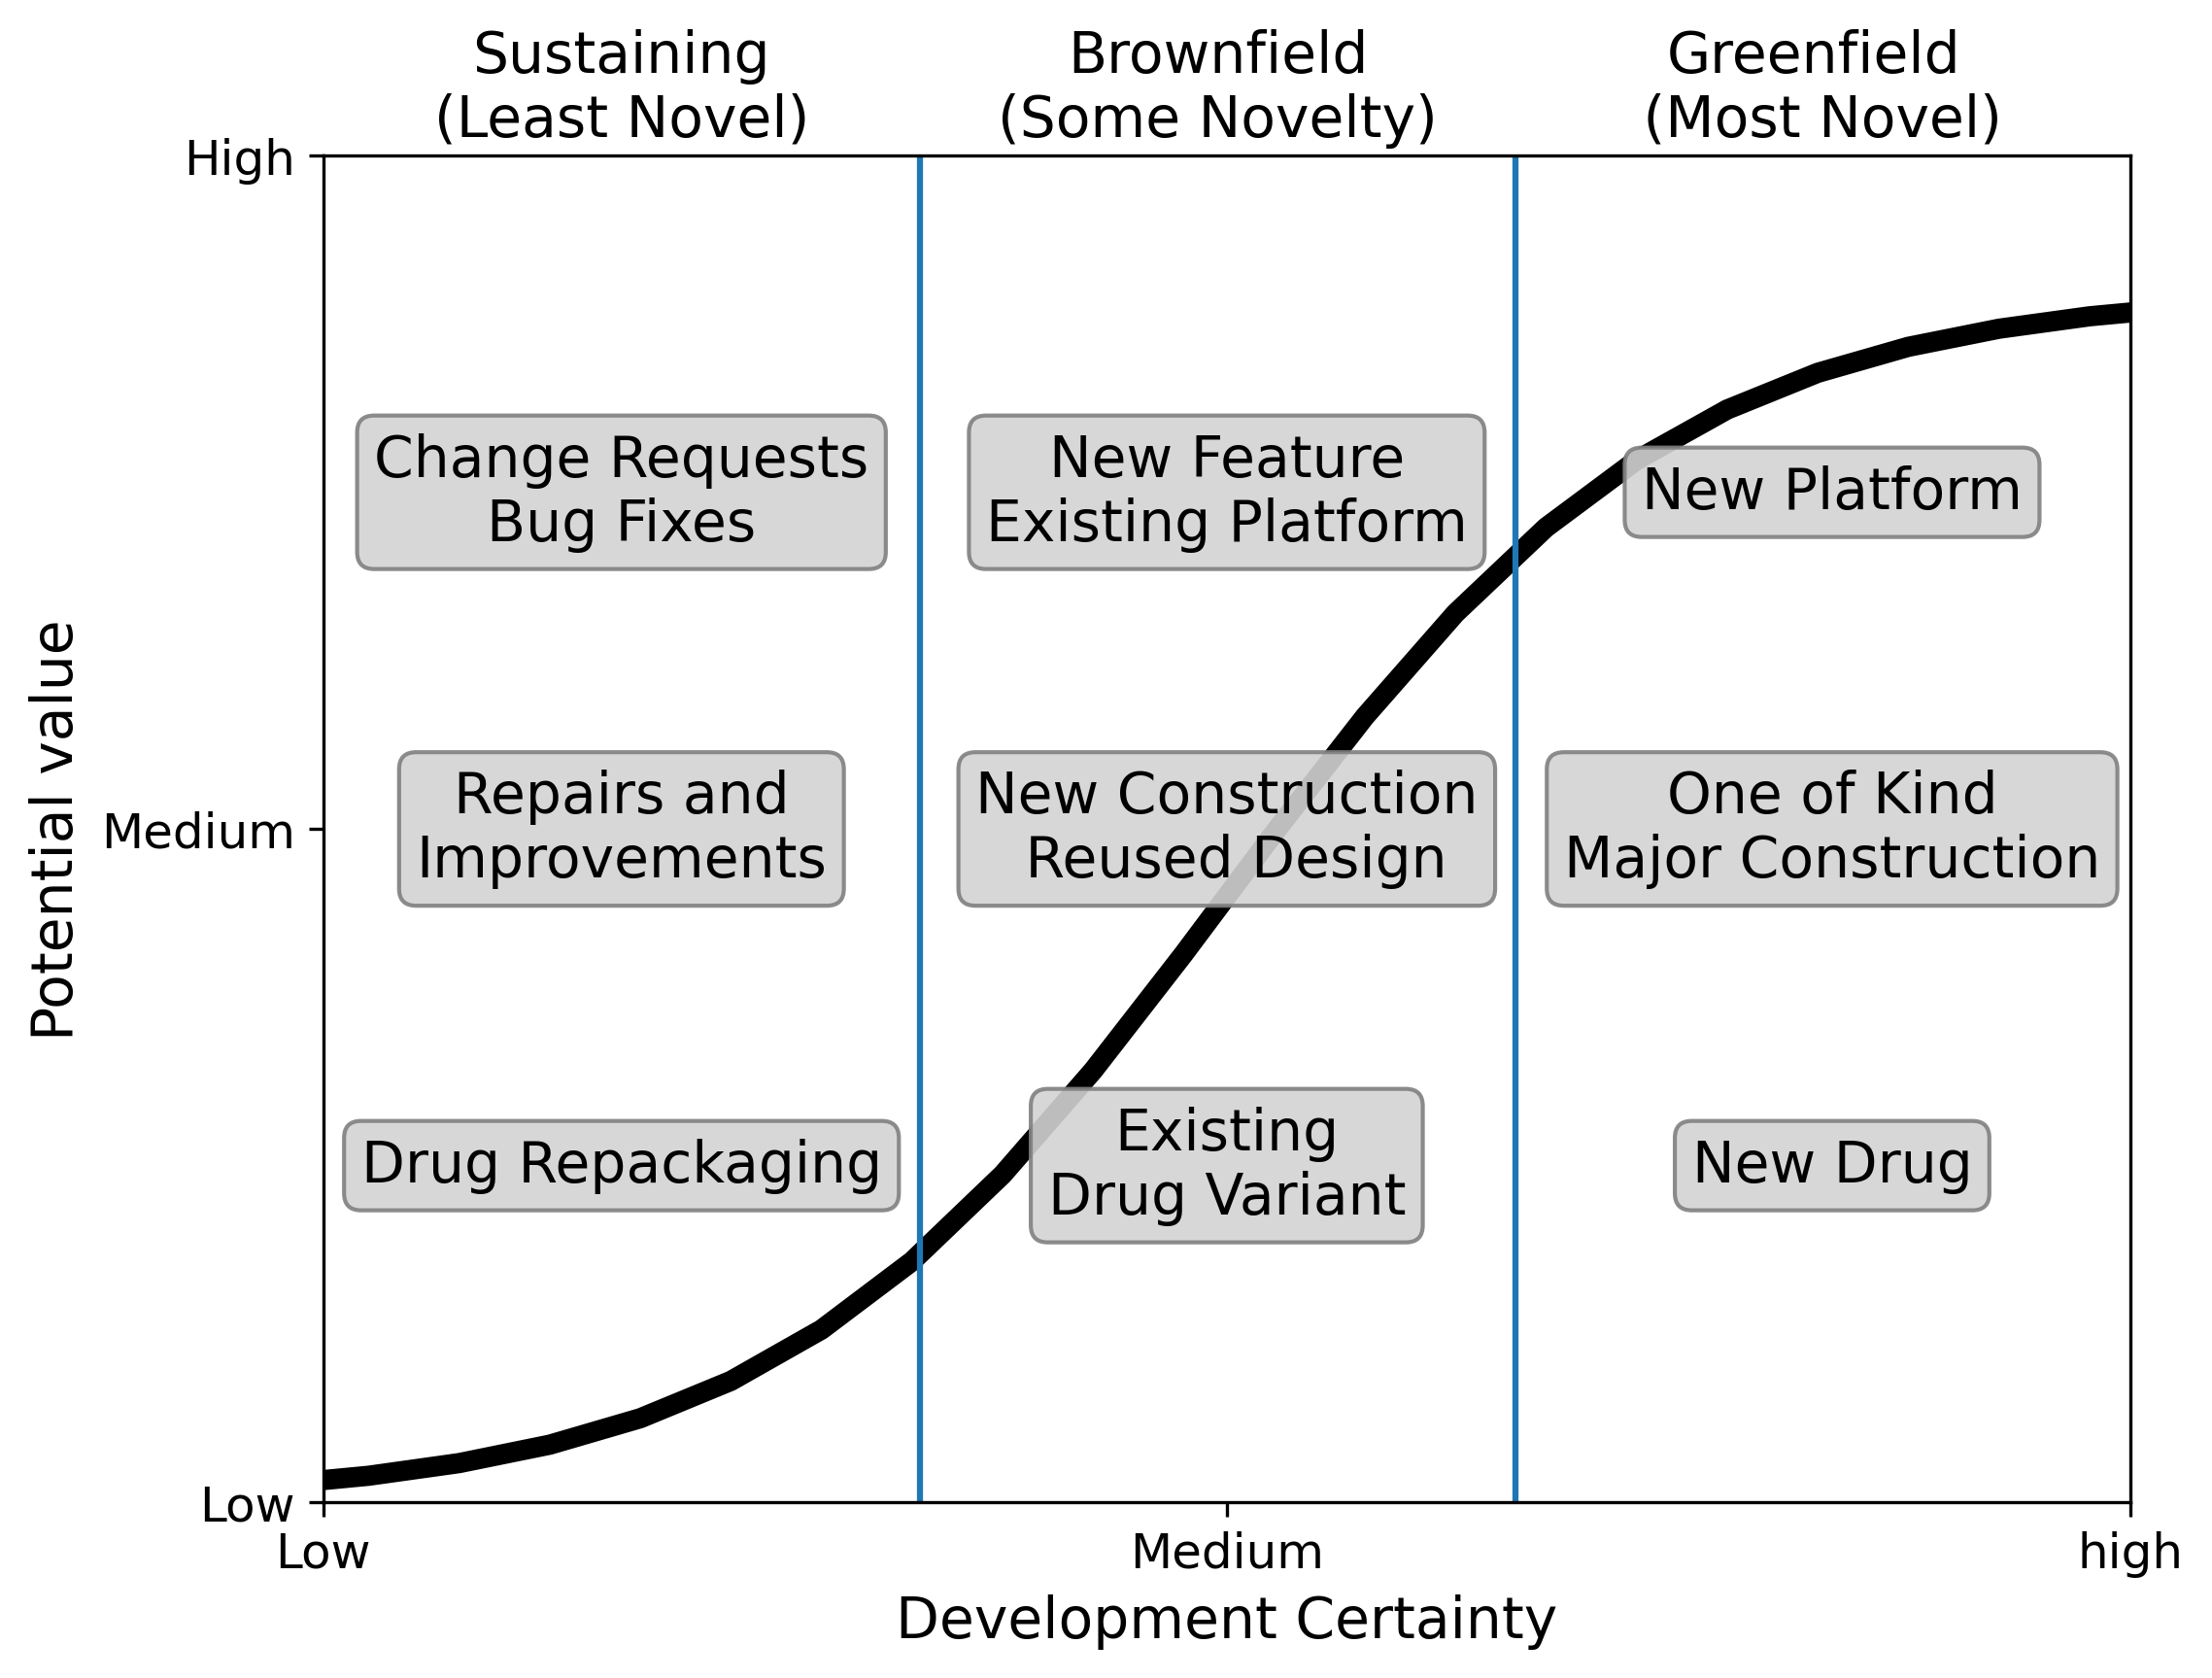

Figure 1

In summary:

Uncertainty is inherent in some development efforts and should be embraced and measured to inform decisions.

# These Principles Work Across Domains.

[Mind map goes here]

Figure

# Quantifying Uncertainty

Recall this oft-mentioned quote:

*"When you can measure what you are speaking about and express it in numbers, you know something about it, but when you cannot measure it when you cannot express it in numbers, your knowledge is meager and unsatisfactory."*

- William Thomson, also known as Lord Kelvin (Thompson, 1889):

This is commonly paraphrased as:

*"If you cannot measure it, you cannot improve it."*

The math and science of uncertainty is probability theory. Probability theory introduces *uncertain variables*, often confusingly called ‘random variables.’ These variables are not strictly random but are invaluable for managing in the face of uncertainty.

An uncertain variable represents a quantity that can take on different values, each with an associated probability function. An example of an uncertain probability function is the familiar ‘bell-shaped’ curve. Uncertain variables’ probability functions have numerical values such as the mean, standard deviation, and percentiles, which can be used to measure expected values and uncertainty.

They are used in a wide range of disciplines:

* **Discrete Probabilities** in terms of the ratio of desired outcomes to all possibilities. This is the use case for gambling odds such as poker hands or dice rolls. These are discrete probabilities since there are a finite number of possibilities.
* **Population** **statistics** involve measures such as mean, median, standard deviation, and variance, which infer the characteristics of an entire population by measurements on a population sample.
* **Statistical significance** in experimental design entails hypothesis testing and p-values, which evaluate whether experimental results are likely to be due to chance.
* **Investing Risk and Reward** deals with spending money today (i.e., putting it at risk) with the hope of and expectation of receiving more. The general principle is that higher-risk investments should have a reasonable probability of higher reward.

Each applies probability differently. We will approach probability from the investment perspective for the reasons described above. In particular, a project's time and cost to complete and its return on investment are all uncertain variables,

# Bayesian Reasoning: Learning from Data

You may be aware of the recent resurgence of Bayesian reasoning. See for examples (Palmer 2022; Chivers 2024; Oxford 2024). Bayesian reasoning provides the means for updating the probability function of an uncertain variable given new information. It uses Bayes’ Theorem, an elemental feature of using uncertain variables. It is well suited for dealing with PPM since we have initial estimates and data streams as projects progress.

While Bayesian reasoning has been around for centuries, its practical application was often limited by the complexity of the calculations. However, recent decades have witnessed a resurgence of Bayesian methods, fueled by advancements in computing power and the development of sophisticated software. Modern computers can now handle the intensive computations required for Bayesian analysis. This has made Bayesian reasoning feasible for broader applications, allowing researchers and practitioners to tackle complex problems involving uncertainty and incomplete information in fields like machine learning, genetics, and finance. The recent resurgence of probabilistic thinking has revolutionized both science and business.

Now is the time to apply Bayesian techniques to development projects and portfolios.

This book will arm the reader with the mindset and intuitions to be a Bayesian. Chapters 1 and 2 provide the mindset and intuitions for taking a Bayesian approach to dealing with uncertainty and risk. Appendices 1 and 2 explain the mathematics behind these ideas at an undergraduate level.

# Taking an Investment Perspective of Success

The fundamental task of project management is to create value. This raises the question of what the value of an incomplete project is. You can’t know if you are creating value unless you can answer this question. Two answers are **clear, simple, and wrong:**

1. A project is worth what has been spent so far to develop.

This is the sunk-cost fallacy of all investing. You may have squandered all the sunk costs with ineffective management.

1. A project is worth nothing until it is delivered.

This fails the sanity test. Suppose you are one day before a successful delivery. Is it true that the project is worthless?

The correct answer is an option-based approach. Consider the following: Suppose your organization is up for sale, and the purchaser sees value in your incomplete project. This actually happens when setting the acquisition price.

In this case, the purchaser is buying the right to complete the project and reap the future benefits. This is analogous to a stock call option*[1]*.

How would the option be evaluated? The smart purchaser is unconcerned with the seller’s sunk cost. With this information, the purchaser computes the probability of future return and sets a price based on the desired ROI.

This call option approach has several advantages:

* It provides a sensible measure of the value of an incomplete project: What would I sell it for if there were a market for it?
* It enables good stakeholder discussions.
* It creates a measure for comparing projects at different stages of development for ongoing portfolio management.
* It rewards good project management by reinforcing uncertainty reduction and avoiding the mistake of working on the ‘low-hanging fruit’ early in the project to show value, putting off the riskier items.

# Evolution, Not Revolution

The book discusses how to use Bayesian reasoning to enhance, not replace, current industry practices such as earned value management (PMI 2020), risk management (Alleman and Quigley 2024a; Smart 2020), risk analysis (Mun 2003; Aven and Thekdi 2022), and program portfolio management (Dixit and Pindyck 1994).

This book will provide insight and the tools to navigate through the fog. We will focus on applying probabilistic thinking to the economics and execution of programs and projects, providing examples and access to working web-based applications.

# Book Summary

The book is divided into four main sections, each containing several chapters.

## Section 1: Foundations

This section outlines the foundational concepts used throughout the book. It should be read by everyone who needs to move beyond common handwaving to reason about and discuss uncertainty and risk precisely and unambiguously. It also sets the perspective and mindset for the rest of the book.

**Chapter 1** **Uncertain Variables**

This chapter introduces the elementary math tool for specifying uncertain continuous variables and probability density functions (PDFs). It requires only high school math and uses explanations, examples, and graphics to enable the reader to understand and apply them for taking action. They are used throughout the text.

**Chapter 2** **Uncertainty, Risk, and Information**

This chapter addresses the term 'risk,' often used loosely, leading to confusion and misunderstandings. It discusses the risks that can be managed, the relationship between risk and uncertainty, and how risk can be measured. It also continues the intuitive discussion of probability introduced in Chapter 1.

**Chapter 3 Project Economics**

This chapter introduces using uncertain variables to compute an uncertain, risky project's net present value and return on investment. These can be used to track value creation and make investment decisions. We consider project economics broadly beyond meeting narrow project goals. Even if a project is on track to meet its specified requirements, does it make economic sense to release it now and incur the post-delivery costs and risks, or is further investment in quality justified before delivery? No system is perfect, so the chapter asks, "Is it good enough to ship?" The analysis bridges the accounting view of project value with an investment perspective to determine the value of an in-progress project (hint: it's not zero). This valuation approach can complement earned value metrics to assess if the project is on track to deliver its intended value.

**Chapter 4, Portfolio Management,** expands project economics to managing a portfolio of risky projects at different stages of development. It will show how to balance go/no-go decisions against chartering new efforts to maximize the organization's return on assets.

## Section 2: Risk Informed Project Management

This section applies the foundations to project management, following the project lifecycle to show how to make informed decisions in the face of uncertainty and track and manage the progressive reduction of uncertainty.

**Chapter 5** covers project chartering in the face of uncertainty. It includes a taxonomy of project types based on their risk/reward profile. It also discusses probabilistically setting project goals and commitments, including firm targets and the tradeoffs between cost, schedule, and quality.

**Chapter 6** discusses meeting commitments by introducing vital probability-based measures and management practices for project success. These include leveraging earned value data to provide ongoing feedback on the likelihood of meeting commitments.

## Section 4: Connecting with Established Practices

Project and program management are mature disciplines with established practices, some mandated in specific domains. The concise chapters in this section explain how the book's techniques relate to these practices. The main idea is that they enhance, rather than replace, the following:

* **Chapter 7**. Risk Analysis
* **Chapter 8**. Cost, Schedule, and Performance Estimation
* **Chapter 9**. Uncertainty-Informed Earned Value Management
* **Chapter 10**.Uncertainty-Informed Agile
* **Chapter 11**. Root Causal Analysis
* **Chapter 12**. Domain-specific Practices
  + Construction
  + Aerospace and defense
  + Systems Integration
* **Chapter 13** Uncertainty-Informed DevOps

## Appendices: Technical Background

**Appendix 1** explains the probability computations used throughout the book, such as

Monte Carlo simulations and joint probabilities.

**Appendix 2** introduces the probability theory used to measure uncertainty and risk throughout the book. Beyond the 'ratio of successes over trials' definitions, it presents a broader, axiomatic view of probability, including the Bayes formula suitable for the sparse data typical in project and program management.

**Appendix 3** describes the Bayesian algorithm underlying the techniques in Chapters 5 and 6 to learn completion and spending velocities.

# Your Journey

In systems project and program management, multiple stakeholders play essential roles throughout the lifecycle. These stakeholders can be grouped based on their primary concerns:

* Executing and Delivering:
  + Project Managers: Responsible for planning, executing, and closing the project day-to-day to meet scope, time, and cost constraints.
  + Project Team Members such as developers, engineers, and architects are actively involved.
  + Change Management Team: Specialists who manage the organizational impact and adoption of project-driven changes.
  + Quality Assurance Team: Responsible for validating the quality of project deliverables, often through testing.
* Planning and Chartering:
  + Project Sponsors: Executives or senior leaders who provide funding, set strategic direction, and are ultimately accountable for project success.
  + Business Analysts: Define business requirements and ensure project outputs meet those needs.
  + Financial Analysts/Controllers: Manage the budget, analyze costs, and ensure economic viability.
  + Program Managers: Oversee the overall direction and integration of interrelated projects.
  + Portfolio Managers: Align a portfolio of projects and programs with organizational goals and objectives.

While each role has distinct responsibilities, effective communication and collaboration across these groups often need improvement. This book bridges these gaps by providing a shared language and perspective on managing uncertainty and risk.

We recommend:

* Everyone read Section 1 on critical concepts and probabilistic thinking.
* Execution and delivery teams focus on Section 2, which discusses project-level management, with leads reading Chapter 6, which examines economic tradeoffs.
* Planning and oversight roles concentrate on Section 3 on program-level considerations and Chapter 3 on project chartering.
* Readers consult the targeted chapters in Section 4 related to specific practices used in their organizations.

# Bibliography

Bremmer, Charles. 2003. “Concorde: End of a Dream.” The Guardian. November 2003. URL: https://www.theguardian.com/world/2003/nov/01/transport.travelnews.

Chivers, Tom. 2024. *Everything Is Predictable: How Bayesian Statistics Explain Our World*. Atria/One Signal Publishers.

“Defense Acquisitions: Key Decisions to Be Made on Future Combat System.” 2007. GAO-07-376, 2007. U.S. Government Accountability Office (GAO).

Dixit, A.K., and R.S. Pindyck. 1994. *Investment under Uncertainty*. ‎ Princeton University Press.

Dolfing, Henrico. 2019. “Case Study 1: The £10 Billion IT Disaster at the NHS.” January 20, 2019. https://www.henricodolfing.com/2019/01/case-study-10-billion-it-disaster.html.

Feickert, Andrew. 2006. “The Army’s Future Combat Systems (FCS): Background and Issues for Congress.” Congressional Research Service.

Gates, Robert. 2014. *Memoirs of a Secretary at War*. Alfred A. Knopf.

Kovach, Steve. 2015. “Google Glass Is Dead: The Sad Story of a Total Failure.” Business Insider. January 2015. URL: https://www.businessinsider.com/google-glass-is-dead-2015-1.

Metz, Rachel. 2019. “What Happened to Google Glass?” Wired. February 2019. https://www.wired.com/story/what-happened-to-google-glass/.

“National Health Service – UK.” 2008. *Catalogue of Catastrophe* (blog). September 2008. https://calleam.com/WTPF/?p=2003.

Oxford, Clarence. 2024. “Mathematics Behind AI-Powered Space Travel Risk Assessment Models.” *Space Daily* (blog). October 15, 2024. https://www.spacedaily.com/reports/Mathematics_Behind_AI_Powered_Space_Travel_Risk_Assessment_Models_999.html.

Palmer, T. 2022. *The Primacy of Doubt*. Basic Books.

Smart, C. 2020. *Solving for Project Risk Management: Understanding the Critical Role of Uncertainty in Project Management*. McGraw Hill.

“Why Concorde Was a Failure.” 2003. The Economist. 2003. https://www.economist.com/business/2003/10/23/why-concorde-was-a-failure.

1. This is sometimes called a ‘real option’.